**EVIDENCE FOR MY ONLINE PLATFORM ACCOUNTS**

**1.LINKED IN**

<https://www.linkedin.com/in/tili-kiptiken-7a3606266/>

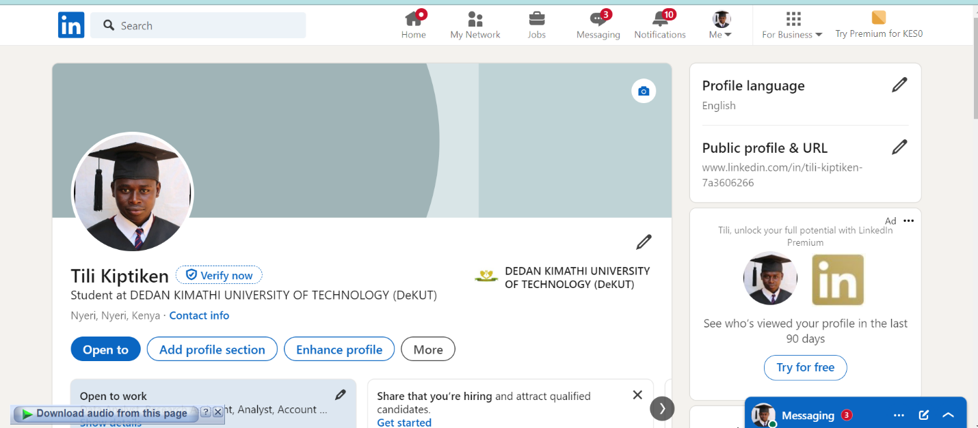2.WHATSAPP  
<https://wa.link/bwj64j>

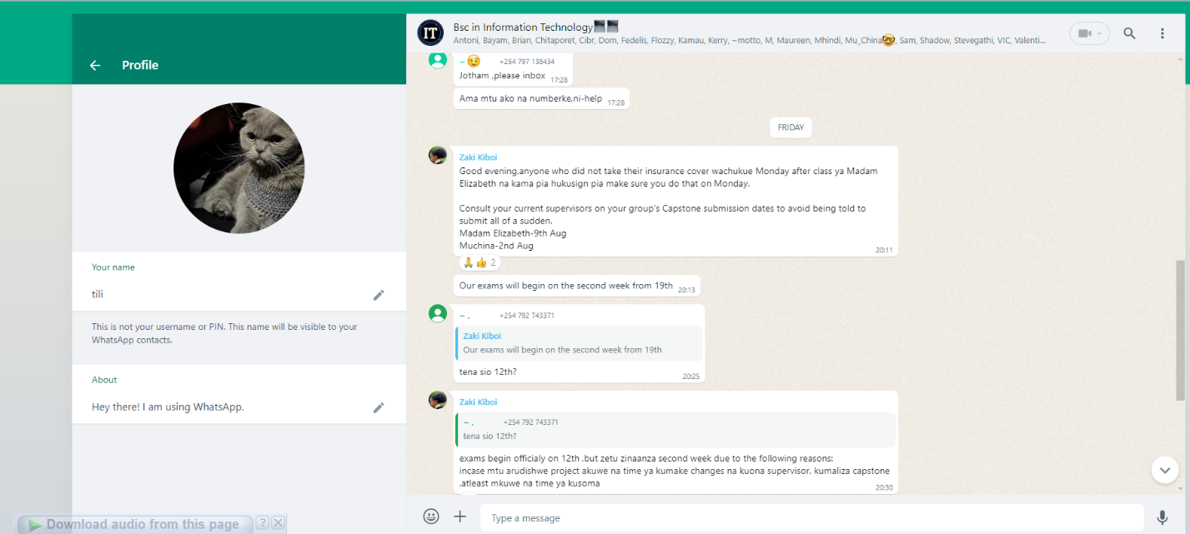

3.**TWITTER**

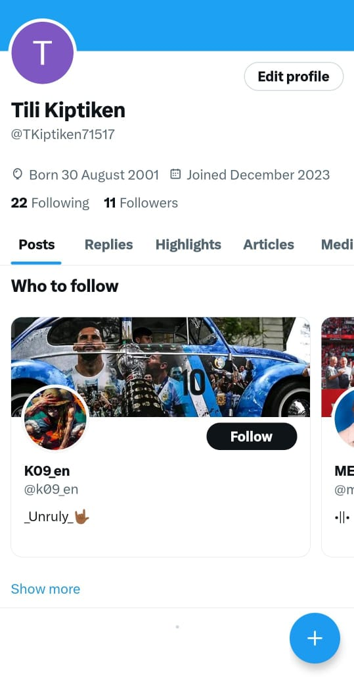

<https://x.com/TKiptiken71517?t=tiYkdgCwOOp3NTA5anr_Dw&s=09>

**4.INSTAGRAM**

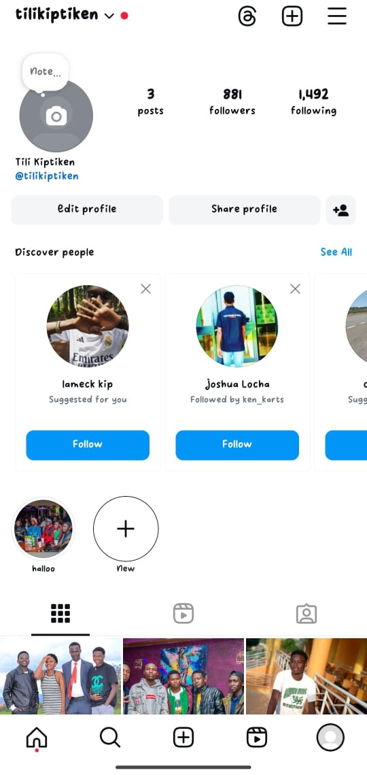

5.FACEBOOK

<https://www.instagram.com/tilikiptiken?igsh=MXNiMDBrNW9rNDBjMg==>

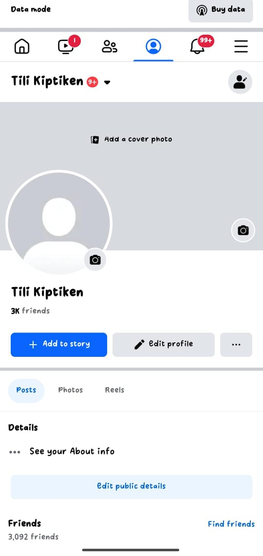

<https://www.facebook.com/tili.kiptiken.7?mibextid=ZbWKwL>